SIMATS ENGINEERING
ASSESSMENT TOOL 3: Application Based Questions

COURSE NAME: | Cloud Computing and Big Data Analytics | COURSE CODE: | CSA1506

COURSE OUTCOME COVERED
CO2: Analyze virtualization architectures to identify performance and security issues in cloud computing environments. (BL3)
Assessment Tool Weightage: 10%

Dave's Taxonomy: Manipulation (Level 2)  Question Count: 5 | Total Marks: 25

Code of Conduct
I Logeshwaran R-192511175 (Name / Reg No) certify that this submission is my original work and that I have adhered to the guidelines specified for this assessment.
I understand that any violation of academic integrity rules will result in disciplinary action.
Signature of the student: 

Assessment Tasks

Application Based Questions

- A company experiences unpredictable traffic spikes during seasonal sales. Explain how cloud auto-scaling and load balancing can handle this demand efficiently. How does this approach reduce downtime and improve user experience? What role do monitoring tools play in this setup? Relate your answer to a real-world e-commerce scenario.
Answer:
A company faces unpredictable traffic spikes during seasonal sales and needs its infrastructure to handle demand efficiently without downtime.
1. How Auto-Scaling and Load Balancing Handle the Spike
- Load balancing: A load balancer sits in front of the web/app tier and distributes incoming shopper requests evenly across all healthy server instances, so no single server gets overwhelmed while others sit idle.
- Auto-scaling: An auto-scaling group watches metrics like CPU utilization or request count and automatically launches new server instances when demand rises (e.g., during a flash sale) and terminates them once traffic falls back to normal - so capacity always matches demand instead of being fixed.
- Supporting layers: A cache (e.g., Redis) in front of the database absorbs repeated reads of product/catalog data, and read replicas scale out database read capacity, preventing the database from becoming the bottleneck once the app tier has scaled.
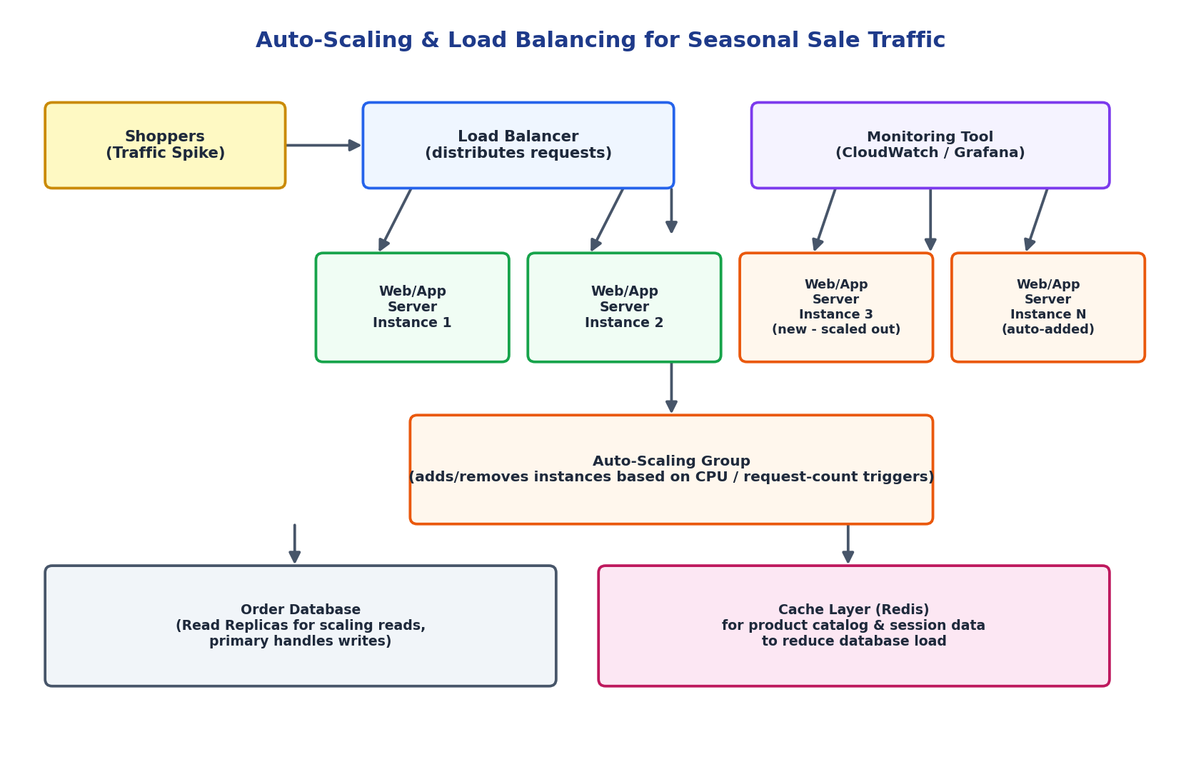
Figure 1.1: Auto-scaling and load-balanced architecture for handling seasonal e-commerce traffic spikes.
2. Reducing Downtime and Improving User Experience
- Load balancers perform health checks and instantly stop routing traffic to a failed instance, so a single server crash never causes a visible outage.
- Auto-scaling adds capacity proactively (or within minutes) instead of the site slowing to a crawl or timing out under load, keeping page-load and checkout times fast.
- Because scaling is automatic, the company avoids the two failure modes of fixed capacity: over-provisioning (wasted cost) or under-provisioning (crashes during the sale, the worst possible time).
3. Role of Monitoring Tools
Monitoring tools (e.g., Amazon CloudWatch, Grafana/Prometheus) are what make auto-scaling intelligent rather than reactive-too-late. They continuously track CPU, memory, request latency, and error rates, feed those metrics into the scaling policies that decide when to add or remove instances, and trigger alerts to the operations team if a scaling action itself is insufficient - enabling both automated response and human oversight during the highest-risk traffic windows.
Real-World Example: During a Flipkart Big Billion Days or Amazon Great Indian Festival sale, traffic can jump 10-20x within minutes of the sale opening. Auto-scaling groups behind a load balancer allow the platform to add hundreds of server instances in near real time, while monitoring dashboards let engineers watch checkout latency and database load live, stepping in manually only if automated scaling policies fall behind the surge.

- An organization wants to store large volumes of backup data securely in the cloud.
Discuss how cloud storage solutions ensure durability and data redundancy.
How can encryption and access control protect sensitive backup data?
Explain the cost advantages compared to traditional storage systems.
Provide an example of a disaster recovery use case.
Answers:
An organization wants to store large volumes of backup data securely in the cloud, with durability, protection, and cost-efficiency.
1. Durability and Data Redundancy
- Cloud storage services automatically replicate every object multiple times within a region (across separate Availability Zones), so the failure of a single disk, server, or even a whole data-center building does not cause data loss.
- For additional protection, data can be replicated cross-region, so an entire region-level disaster still leaves a usable copy elsewhere.
- This design is what allows cloud providers to advertise extremely high durability figures (often 99.999999999% - '11 nines') far beyond what a single on-premises disk array can achieve.
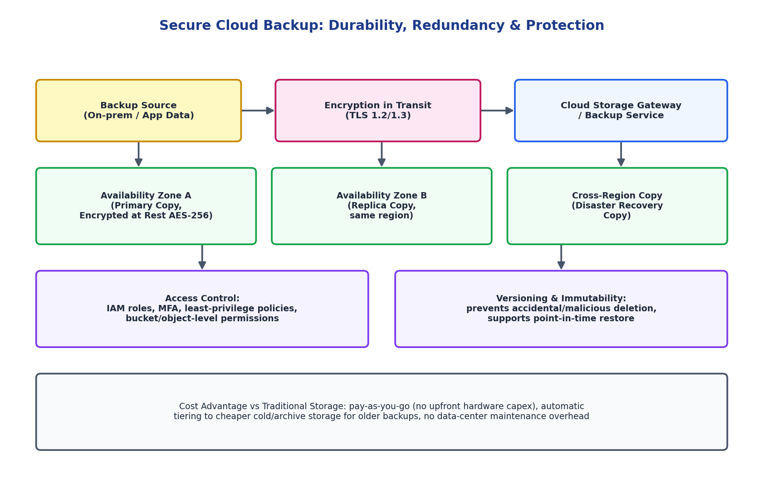
Figure 2.1: Durable, redundant, and access-controlled cloud backup architecture.
2. Protecting Sensitive Backup Data
- Encryption: Data is encrypted in transit (TLS) while being uploaded/downloaded, and encrypted at rest (AES-256) while stored, with encryption keys managed through a Key Management Service (KMS) so even the storage provider cannot read the raw backup content without authorization.
- Access control: Fine-grained IAM policies restrict who (which user, service, or application) can read, write, or delete specific backups, combined with multi-factor authentication and least-privilege roles, so a compromised low-level account cannot touch the entire backup set.
- Versioning and immutability: Object versioning and retention locks mean even an accidental or malicious delete/overwrite can be rolled back to a prior good version, rather than being permanently lost.
3. Cost Advantages over Traditional Storage
- No upfront capital expenditure on physical disk arrays, tape libraries, or a backup data center - pay only for storage actually used.
- Automatic storage tiering moves older/rarely accessed backups to cheap cold or archive storage classes without manual intervention.
- Eliminates ongoing costs of hardware maintenance, power, cooling, and refresh cycles that traditional on-premises backup infrastructure requires.
Real-World Example: A hospital chain backs up patient records nightly to cloud object storage with cross-region replication and versioning enabled. When a ransomware attack encrypts files on the primary on-premises server, the IT team restores from the previous day's immutable cloud backup - avoiding both data loss and any ransom payment, which is a classic disaster-recovery use case for cloud backup.

- A mobile app company plans to deploy its application globally. Explain how content delivery networks (CDNs) improve performance and reduce latency. How do edge servers enhance user experience across regions? Discuss how cloud providers support global availability. Relate this to a real-time streaming or gaming application.
Answer:
A mobile app company plans to deploy its application globally and needs consistent performance for users on every continent.
1. How CDNs Improve Performance and Reduce Latency
A Content Delivery Network caches static and semi-static content (images, videos, app assets, API responses that don't change per-request) at a large number of geographically distributed edge locations. Instead of every user request traveling all the way to a single origin server, it is served from the nearest edge location - cutting the physical distance data has to travel and therefore cutting round-trip latency dramatically.
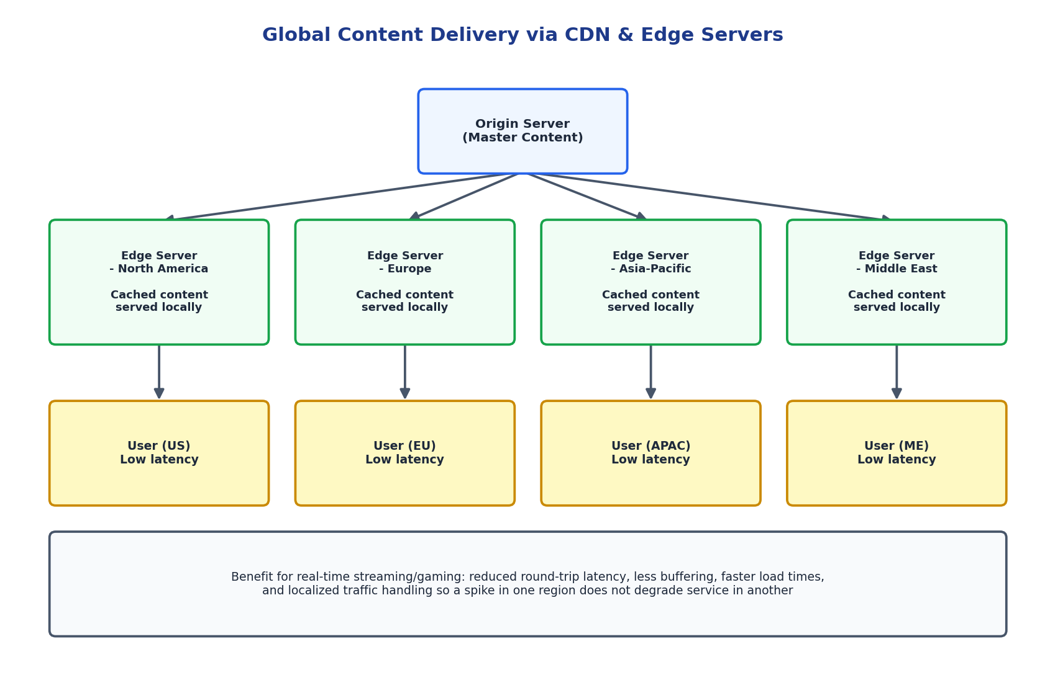
Figure 3.1: CDN edge servers placed close to users in each region, reducing round-trip latency.
2. How Edge Servers Enhance Experience Across Regions
- Users in North America, Europe, Asia-Pacific, and the Middle East each connect to their own nearby edge server rather than a single distant origin, so load times feel consistent regardless of the user's location.
- Edge servers also absorb traffic locally, so a surge of users in one region (e.g., a viral moment in Asia) does not add load to servers serving other regions.
- Some CDNs support edge compute (running small pieces of application logic at the edge itself), further reducing the need to reach the origin for simple operations like authentication checks or A/B test routing.
3. How Cloud Providers Support Global Availability
- Cloud providers operate CDN services (CloudFront, Azure CDN, Cloud CDN) integrated with their global network backbone, which is typically faster and more reliable than the public internet for long-distance hops.
- Multi-region deployment of the origin/backend, combined with global DNS-based traffic routing, ensures that even the origin itself is reachable quickly from anywhere, and can fail over between regions if one becomes unavailable.
Real-World Example: A real-time multiplayer mobile game deploys game servers in multiple regions and uses a CDN for game assets and patch downloads. Players in India connect to an Asia-Pacific edge/game server for low-latency matches, while players in Germany connect to a European one - keeping in-game latency low enough for competitive play, which directly affects user retention for latency-sensitive games and live-streaming apps alike.

- A financial institution requires strict compliance and data security in cloud usage.
Explain how cloud providers support regulatory compliance and auditing. What role do logging, monitoring, and encryption play in security? How can the company ensure data sovereignty requirements are met? Give an example involving sensitive financial transactions.
Answer:
A financial institution must meet strict regulatory compliance and data security requirements while using cloud infrastructure for sensitive financial transactions.
1. How Cloud Providers Support Compliance and Auditing
- Major cloud providers maintain independently audited certifications (PCI-DSS for payment data, ISO 27001, SOC 2, and region-specific frameworks like RBI guidelines or GDPR) and publish compliance reports the institution can rely on for its own regulatory audits.
- Providers operate under a shared-responsibility model: the provider secures the underlying infrastructure and certifies it, while the institution is responsible for correctly configuring identity, encryption, and access controls on top of it.
- Built-in audit and compliance dashboards (e.g., AWS Audit Manager, Azure Compliance Manager) map the institution's actual cloud configuration against required regulatory controls continuously, rather than only at audit time.
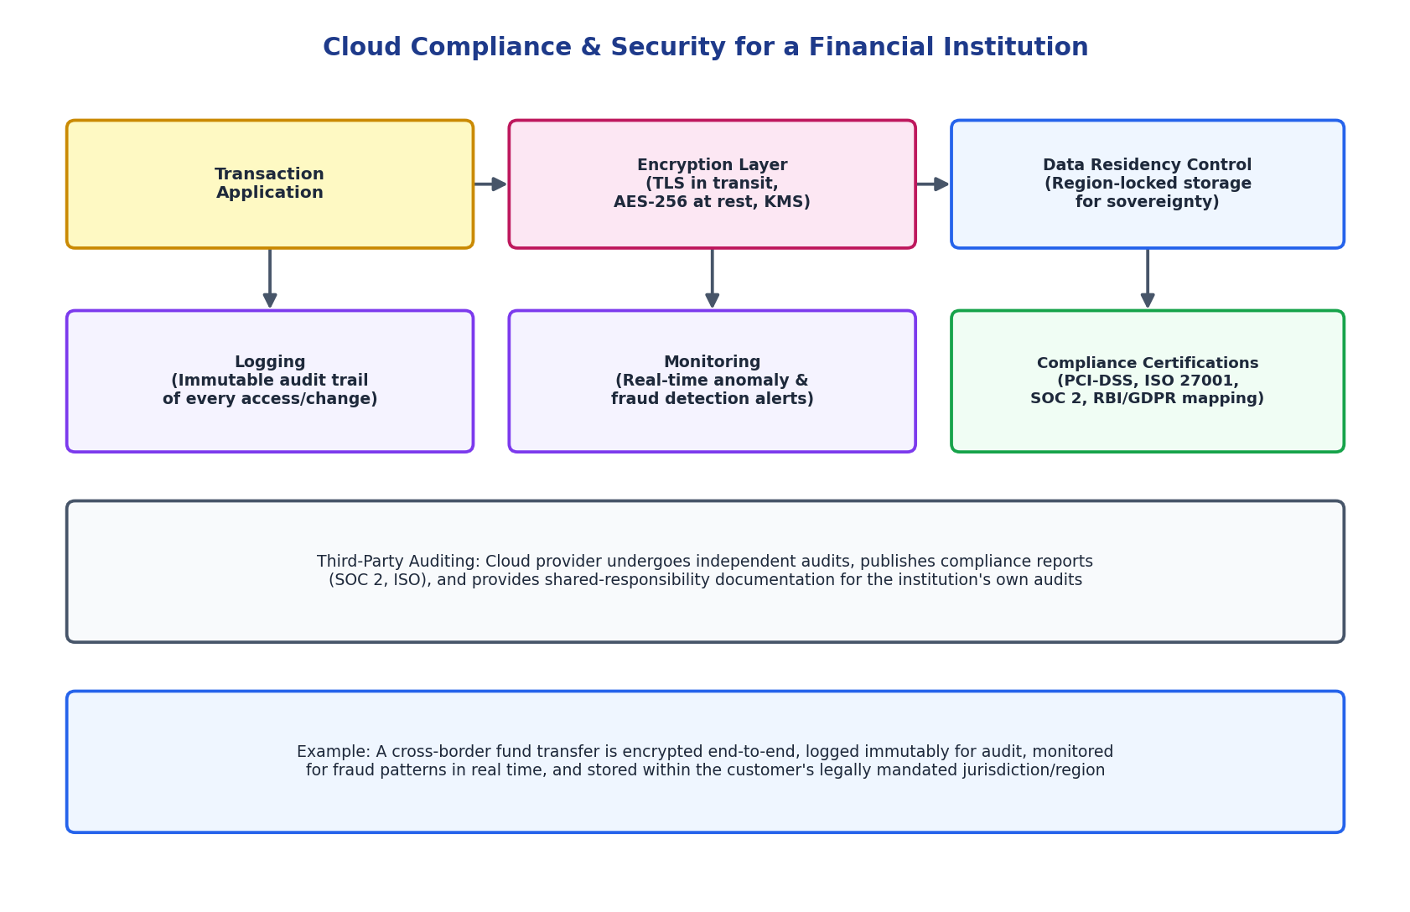
Figure 4.1: Compliance-oriented cloud architecture with logging, monitoring, encryption, and data residency controls.
2. Role of Logging, Monitoring, and Encryption
- Logging: Every access to and change in financial data is written to an immutable audit trail (e.g., AWS CloudTrail), which regulators require to reconstruct exactly who did what and when - critical evidence during any compliance investigation or breach inquiry.
- Monitoring: Real-time monitoring and anomaly detection flag suspicious behavior (unusual transaction patterns, access from unexpected locations) as it happens, supporting both fraud prevention and regulatory obligations to detect and report incidents quickly.
- Encryption: TLS protects transaction data in transit, AES-256 protects it at rest, and a centrally managed Key Management Service (KMS) - sometimes with the institution holding its own keys - ensures that even the cloud provider cannot read the raw financial data.
3. Meeting Data Sovereignty Requirements
Data sovereignty means financial data must legally remain within a specific country or region's jurisdiction. Institutions meet this by selecting cloud regions physically located within the required jurisdiction, using storage and backup policies that pin data (and its replicas) to that region only, and verifying through the provider's compliance documentation that no data is transferred outside approved boundaries even for backups or disaster recovery.
Real-World Example: A bank processing a cross-border wire transfer encrypts the transaction data end-to-end, logs every step of the transfer immutably for audit, runs it through real-time fraud-monitoring rules, and ensures the customer's account data itself is stored only within the region required by that country's financial regulator - satisfying compliance, security, and sovereignty requirements simultaneously.

- A development team wants to adopt containerization for application deployment.
Explain how containers differ from virtual machines in terms of performance and resource usage. How does orchestration (like Kubernetes) simplify deployment and scaling? Discuss portability benefits across different cloud environments.
Provide an example of a microservices-based application.
Answer:
A development team wants to adopt containerization for deploying its applications instead of relying purely on traditional virtual machines.
1. Containers vs Virtual Machines
- Resource usage: Each VM bundles a full guest operating system alongside the application, consuming significant CPU, memory, and disk just to run the OS itself. A container shares the host machine's OS kernel and packages only the application and its dependencies, making it far lighter.
- Performance and startup time: VMs typically take minutes to boot because they must start an entire OS. Containers start in seconds since there is no OS to boot, only the application process itself, which also means far higher application density per physical host.
- Isolation trade-off: VMs offer stronger isolation (separate kernels) which suits multi-tenant or highly sensitive workloads; containers offer weaker isolation than VMs but are increasingly hardened (namespaces, cgroups) and are the standard choice for fast-moving microservices.
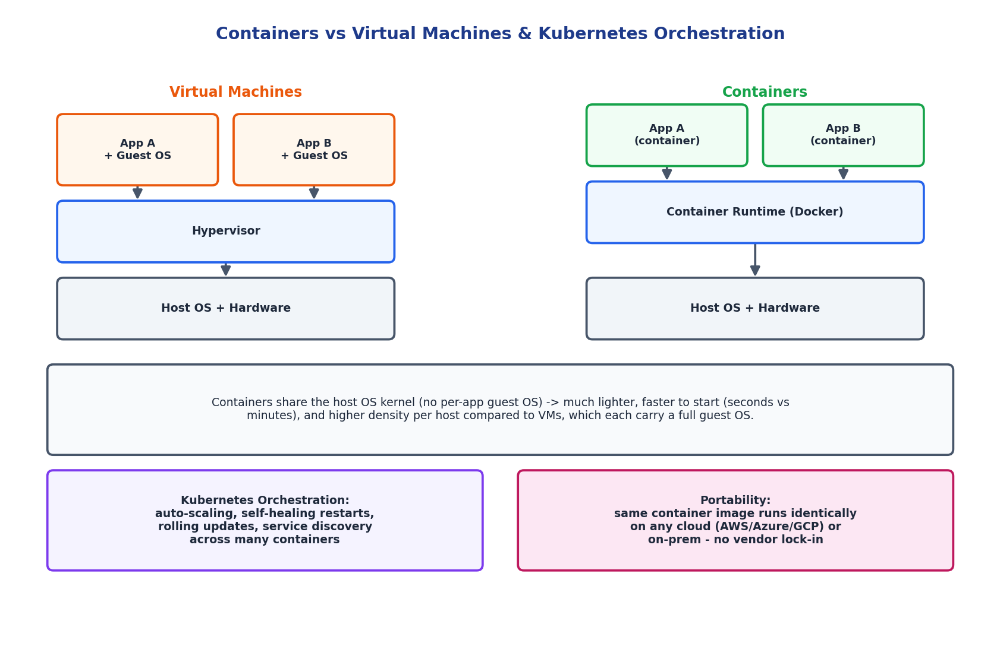
Figure 5.1: Architectural comparison of virtual machines and containers.
2. How Kubernetes Orchestration Simplifies Deployment and Scaling
- Kubernetes automatically schedules containers onto available hosts, restarts them if they crash (self-healing), and performs rolling updates with zero downtime when a new version is deployed.
- Horizontal Pod Autoscaling automatically increases or decreases the number of running container instances based on load, similar in spirit to VM auto-scaling but at much finer granularity and speed.
- Built-in service discovery and load balancing let containers find and call each other by service name, without the team manually tracking IP addresses as containers are created and destroyed.
3. Portability Benefits Across Cloud Environments
A container image packages the application with all its dependencies, so the exact same image runs identically on a developer's laptop, in AWS, in Azure, in GCP, or on-premises - eliminating the 'it works on my machine' problem. Combined with Kubernetes being available as a managed service on every major cloud (EKS, AKS, GKE) as well as on-premises, teams avoid vendor lock-in and can move workloads between clouds, or run a multi-cloud/hybrid strategy, with minimal rework.
Real-World Example: An e-commerce platform built as microservices - separate containers for the product catalog, cart, payment, and recommendation services - runs each on Kubernetes. During a sale, only the cart and payment services are scaled up independently, while the recommendation service stays at normal capacity, something far harder to do efficiently with monolithic VM-based deployment.

Application Based Questions Rubric
Criteria | Weightage | Level 4 - Exemplary | Level 3 - Proficient | Level 2 - Developing | Level 1 - Beginning
Relevance to Application | 25% | Response directly addresses the given use case with strong relevance | Mostly relevant response | Partially relevant | Weak relevance
Use of Cloud Concepts | 25% | Applies appropriate concepts accurately | Mostly accurate application | Basic application only | Incorrect concept usage
Practical Insight | 20% | Shows strong real-world understanding | Shows reasonable practical understanding | Limited practical insight | No practical insight
Completeness | 15% | Response covers all required aspects | Covers most aspects | Covers only basic aspects | Incomplete response
Clarity | 15% | Clear and concise answer | Generally clear | Some confusion in expression | Poor clarity

